Fifth Grade Choir
2018-2019
September 2018
Dear Parents and Students,

Your child has selected CHOIR as their choice for Block Music this year. We will meet twice each week for the remainder of the school year and will be singing a variety of songs and exploring the wonderful instrument we carry with us wherever we go: our voice.

We’ll be singing songs that relate to the social studies curriculum (songs about our country), as well as songs that will help us begin to read music. We will sing in two-part harmony and develop skills that will carry over into middle school choir.

As part of the Fifth Grade Choir, students are invited to participate in a special Choral Area Concert exclusive to the Aliso Niguel High School Family. This concert involves elementary, middle, and high school choirs in the area. This concert will take place on Wednesday, December 5, 2018, in the large gym at Aliso Niguel High School. Please save the date for this exciting and unique event!

You do not need to purchase any supplies for 5th grade choir, however, every child will be using a music folder to hold all of their music and other choir paperwork. If you have an extra flat, 2-pocket folder you could send to class, that would be great! Any color or design is fine. We will have plenty of extra folders for anyone who needs one.

Grading
3 Demonstrates grade-level proficiency in the following areas:
- rhythm
- solfege (major scale with Curwen hand signs)
- materials/preparedness
- sound/tone production
- applying instructor(s) directions

2+ Demonstrates grade-level proficiency in most of the following areas & working toward grade-level proficiency in 1-2 areas:
- rhythm
- solfege (major scale with Curwen hand signs)
- materials/preparedness
- sound/tone production
- applying instructor(s) directions

2 Working toward grade-level proficiency in most of the following areas:
- rhythm
- solfege (major scale with Curwen hand signs)
- materials/preparedness
- sound/tone production
- applying instructor(s) directions

2- Working toward grade-level proficiency in all of the following areas:
- rhythm
- solfege (major scale with Curwen hand signs)
- materials/preparedness
- sound/tone production
- applying instructor(s) directions

1 Below grade-level proficiency in all of the following areas:
- rhythm
- solfege (major scale with Curwen hand signs)
- materials/preparedness
- sound/tone production
- applying instructor(s) directions

Donations
- A donation of any amount is gratefully accepted from each family to help offset vocal and instrumental music program costs.
- A suggested donation amount is $25.00
- Only checks are accepted (Please no cash or credit cards)
  - Please make checks payable to CUSD ELEMENTARY MUSIC (write Elementary Music on memo line)
- Donations do not guarantee use of a district instrument, as that process is handled through a lottery system.
- Donations are voluntary and all students will be allowed to participate regardless of donation.
- If you would prefer to donate actual items, our class will regularly use dry-erase markers, No. 2 pencils with erasers, and white & colored copy paper.

Feel free to email us with any questions you may have. We look forward to a great year!

Sincerely,
Mrs. Sharon Evans (shevans@capousd.org) & Ms. Andrea Romero (agromen@capousd.org)

*Please note that the Constitution of the State of California requires that we provide a public education to you free of charge. Your right to a free education is for all school/educational activities, whether curricular or extracurricular, and whether or not you get a grade for the class. Subject to certain exceptions, your right to a free, public education means that we cannot require you or your family to purchase materials, supplies, equipment or uniforms for any school activity, nor can we require you or your family to pay security deposits for access, participation, materials, or equipment.
✂-------------------------------------------------------------------------------------------------------------------------------------------------------------------------
I have read the Choir Welcome Letter and would like my child to 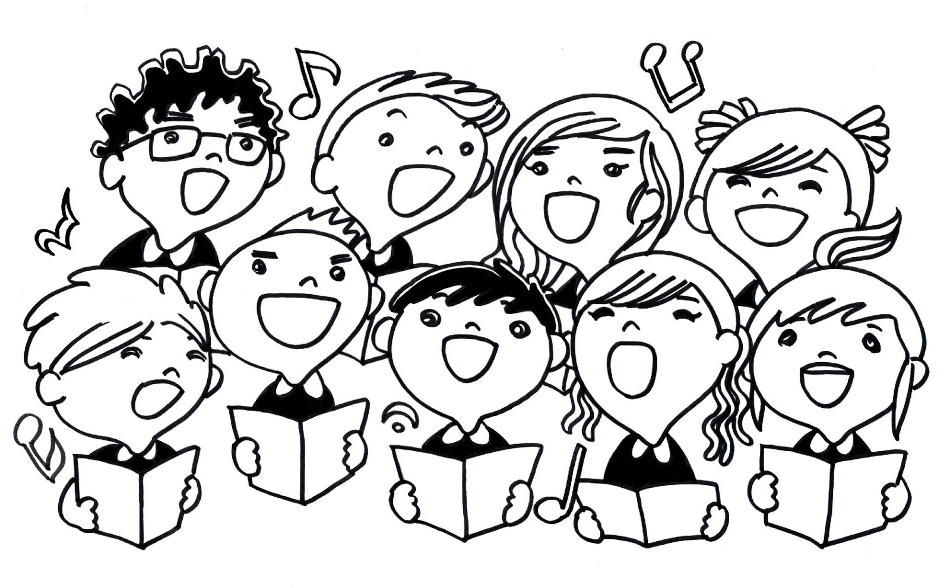
Participate in choir for the 2018-2019 school year.

Print STUDENT’S Name _______________________________________

Parent Signature ______________________________________________

School _______________________________ Classroom Teacher’s Name _______________________
CORO Del QUINTO GRADO
2018-2019

Septiembre 2018

Estimados padres y estudiantes,

Tu niño ha seleccionado CORO como su clase de música este año. Tendremos clases dos veces a la semana por el resto del año escolar, y cantaremos una variedad de canciones y explorar el maravilloso instrumento que siempre llevamos con nosotros donde quiera que vamos: nuestra voz.

Cantaremos canciones relacionadas a la materia de ciencias sociales (canciones acerca de nuestra país), también como canciones que nos ayudará aprender a leer música. Cantaremos en harmonía de dos partes y desarrollaremos habilidades que les servirán en el coro de secundaria.

Los estudiantes del coro del quinto están invitados a participar a la audición para formar parte del prestigioso “Coro de Honor” de todo distrito. El “Coro de Honor” es una gran oportunidad para que los estudiantes participen en una experiencia coral enriquecedora, donde participan los mejores estudiantes de todo el distrito. Más información estará disponible a principios de noviembre.

You do not need to purchase any supplies for 5th grade choir, however, every child will be using a music folder to hold all of their music and other choir paperwork. If you have an extra flat, 2-pocket folder you could send to class, that would be great! Any color or design is fine. We will have plenty of extra folders for anyone who needs one.

Con el fin de compensar el costo de los materiales de clase, partituras, y mantenimiento de los instrumentos, objetos, proyectos de clase, y los materiales de aprendizaje suplementarios, una donación sugerida de $25.00 dólares por familia que participa en la música vocal sería muy apreciada. Donaciones de cualquier cantidad son gratamente aceptadas y los cheques deben hacerse pagaderos a CUSD Elementary Music. Por favor, tenga en cuenta que las donaciones son voluntarias y todos los estudiantes van a participar hayan donado o no * Si prefiere donar materiales, utilizamos regularmente marcadores no-permanentes (para el pizarrón), lápices No. 2, papel blanco y coloreado copia, y cajas de 12 lápices de colores. No dude en contactarse con nosotros con cualquier pregunta que pueda tener con respecto a las donaciones. No dude en enviarnos un correo electrónico con cualquier pregunta que pueda tener. Esperamos un gran año!

Sinceramente,
Sharon Evans (shevans@capousd.org) & Andrea Romero (agromen@capousd.org)

* Tenga en cuenta que la Constitución del Estado de California requiere sé que proporcione educación pública a usted de forma gratuita. Su derecho a una educación gratuita es para todas las actividades escolares / educación, ya sea curricular o extracurricular, y si no se obtiene un grado de la clase. Sujeto a ciertas excepciones, su derecho a una educación gratuita, pública significa que no podemos requerir que usted o su familia compre materiales, suministros, equipo y uniformes para cualquier actividad de la escuela, ni podemos requerir que usted o su familia para pagar los depósitos de seguridad para el acceso, la participación, materiales o equipos.
✂---------------------------------------------------------------------------------------------------------------------------
He leído la carta de bienvenida del Coro y me gustaría que mi hijo participe en el coro este año escolar 2017-2018.

Nombre Imprimir del Estudiante _______________________________________

Firma de los padres ______________________________________________

Escuela _______________________________ Nombre del maestro/a _______________________

